Gath

Welcome to St. Patrick’s Esker/Dodsboro/Adamstown
Newsletter

1st NOVEMBER 2020

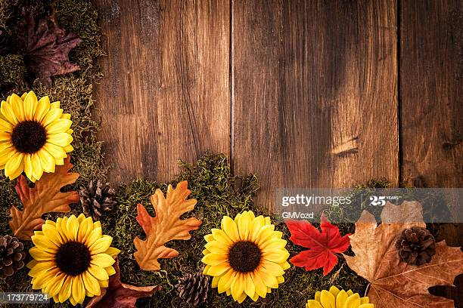

Welcome To
St Patrick’s Esker/Dodsboro/ Adamstown

November 1, 2020
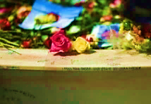
We remember Andrew McDonnell, Patrick & Bridget Behan, John & Ellen Behan, Tommy McCormack, Tony Garvey whose anniversaries occur. John Keenan and Mary Conlon whose funerals took place this week, John Ryan Birthday Remembrance.
Readings – Sun 1st November – The first reading - Apoc 7:2-4; 9-14 - This reading celebrates God’s vision of inclusion for all people, impossible to count who will share in the fullness of his promise of love. The second reading - 1 Jn 3:1-3 - Here is an assurance of God’s lavish who calls us to be his children, because one day we shall see god as he really is. The Gospel – Mt. 5: 1-12 - We are called to have an attitude of the beatitudes as a sign that we are disciples of the gospel way.

Biblical Reflection - Fr. John will be broadcasting a five minute biblical reflection Mon-Fri at 10am on the parish web site – www.st.patrickslucan.ie

Pope’s Intentions for October – Evangelisation: we pray that by the virtue of baptism, the laity, especially women, may participate more in areas of responsibility in the Church. (Intercom magazine)

Seeing your Life Through the Lens of the Gospel -

- You may feel some sympathy with the Jews struggling to cope with 613 laws and wondering were the important ones. Have you ever felt overwhelmed by the rules and regulations of your own tradition? And have you ever been blessed by meeting someone, or reading something, that was able to cut through all the layers and point out to you what is essential in life? Who was that person? What did s/he say or do? Is there some phrase or text that encapsulates such wisdom for you?

- If you were asked what is most important in life, what would your answer be? Recall the experiences and relationships you have had. What are the ones that you treasure most? What has particularly enriched your life? How would you encourage another person who asked you how s/he could life a full life?

